Lab Manual

ME-341 L

# Machine Tools & Machining Lab

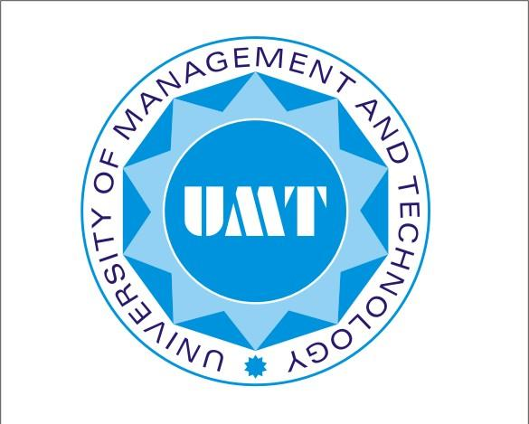

**Resource Person: Touqeer Aslam**

**Student Name:**

**Section:**

**Semester: Fall 2022**

#### Department of Mechanical Engineering

## School of Engineering

University of Management and Technology Lahore